A000-Asia-China-Hongshan Culture-Jade Double Boar-Three-hole device-紅山文化--玉雙獸 --三孔器-Hóngshān wénhuà--yù shuāng shòu--sān kǒng qì



五猴山 原 Wǔ hóu shānyuán

jade double-pig first three-hole device) collected by the San Guan Dian Zi Cun, Lingyuan City, Liaoning Province in 1979 (or unearthed from the Tomb of No. 2 in Chengzishan). Length 9.2, height 2.8, thickness 1.8 cm. Three rows of large round hole body, a hole diameter of 1.9 cm. The central hole has two small perforations through the bottom of the hole, the two sides of each hole has a small hole through the bottom (see Figure 3).

出土器之一是1979年辽宁省凌源市三官甸子村采集(或城子山2号墓遗址出土)的一件兽首三孔玉器（或玉雕双猪首三孔器）。器长9.2、高2.8、厚1.8厘米。器身三个横列大圆孔，孔径为1.9厘米。中央一孔有两个小穿孔透底面，其两侧两孔各有一小孔穿底面（见图三）。

One of the excavations was collected by San Guan Dian Zi Cun in Lingyuan City, Liaoning Province in 1979

(Or Chengzishan 2 Tomb ruins unearthed) a beast first three holes jade (or jade double pig first three holes). Length 9.2, height 2.8, thickness 1.8 cm. Three rows of large round hole body, a hole diameter of 1.9 cm. The central hole has two small perforations through the bottom of the hole, the two sides of each hole has a small hole through the bottom (see Figure 3)

[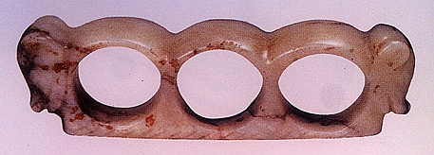](http://photo.blog.sina.com.cn/showpic.html#blogid=a3afa4c60102whkw&url=http://album.sina.com.cn/pic/002ZQLl4gy700yfLs9Z13)

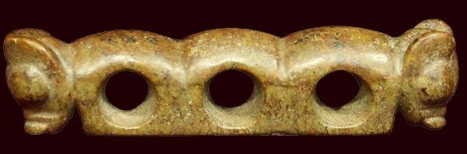

黄山 Huángshān